AHSANULLAH UNIVERSITY OF SCIENCE AND TECHNOLOGY (AUST)

141 & 142, Love Road, Tejgaon Industrial Area, Dhaka-1208.



Department of Computer Science and Engineering Program:

Bachelor of Science in Computer Science and Engineering

**Project Final Report**

Course No: CSE 3118

Course Title: Microprocessors and Microcontrollers Lab

Date of Submission: 28/01/2024

**Project Name: Automatic Irrigation System**

Submitted to

Prof. Dr. Shamim Akhter

Professor, Department of CSE, AUST.

Ms. Lomat Haider Chowdhury

Lecturer, Department of CSE, AUST.

**Submitted by,**

Anamika Saha- 20210104106

Farhana Najnin Mahi- 20210104109

Maliha Akter Miti- 20210104122

**AUTOMATIC IRRIGATION SYSTEM**

**Introduction:**

In today's fast-paced world, we recognize the need to adapt to modern challenges. That's why we have developed the concept of a Automatic Irrigation System. This innovative system utilizes advanced technology to monitor and regulate crucial factors such as moisture, humidity, temperature, and water pump status in the soil, ensuring a balanced and optimized irrigation process. The Automatic Irrigation System is particularly beneficial in areas with irregular rainfall or dry climates. By collecting and analyzing real- time data, this system accurately determines the irrigation needs of a specific land area. It empowers farmers to effectively manage their plants' moisture levels without the need for constant physical presence. By implementing this cutting-edge solution, farmers can ensure that their plants receive the optimal amount of water precisely when they need it. This not only enhances plant health and growth but also maximizes water efficiency, contributing to sustainable agricultural practices.

**Objectives:**

The goal of an Automatic Irrigation System is to preserve the optimal moisture levels of plants, enabling them to thrive without constant surveillance from the owner or caretaker. This innovative device leverages key atmospheric variables such as temperature, humidity, and moisture to create and maintain an ideal environment for plant growth. By automating the irrigation process, the system

aims to provide plants with the right amount of water at the right time, optimizing their growth and health. It seeks to conserve water by utilizing sensors and data to determine the precise irrigation needs of plants, avoiding overwatering or underwatering. The main goal is to create a sustainable and resource-efficient solution that saves time and effort for individuals responsible for plant care, such as farmers or gardeners. Ultimately, the automatic irrigation system aims to promote plant vitality, conserve water, and simplify the irrigation process for improved agricultural practices and lush landscapes. So, here we will discuss about some objectives:

**1.Moisture Level Monitoring**:

Moisture level monitoring involves measuring the amount of water in the soil surrounding the plant roots. This is typically done using moisture sensors that are inserted into the soil. These sensors provide data on the moisture content, allowing you to determine whether the soil is adequately hydrated or if it requires irrigation.

2.**Auto-Irrigation System**:

An Automatic irrigation system, enhanced with Blink technology, automates the process of watering plants based on the moisture level detected by moisture sensors. When the moisture level drops below a predefined threshold, the system, integrated with the Blink platform, activates a water pump or irrigation system to provide water to the plants. What distinguishes this system is its seamless connectivity to smartphones. Through the Blink mobile application, users can remotely control and monitor the irrigation process. With a simple tap on their smartphones, individuals can adjust irrigation settings, check real-time moisture levels, and initiate watering cycles from anywhere. This intelligent integration eliminates the need for manual intervention, offering a convenient and efficient way to ensure plants receive optimal hydration.

3.**Protect Plant from Instant Damage:**

To protect plants from instant damage, additional sensors can be employed. For example, light sensors can detect excessive sunlight, which may harm certain plants. Proximity sensors can detect physical disturbances or intrusions that may cause damage to the plants. By detecting these events, appropriate actions can be taken, such as adjusting the irrigation system, providing shade, or triggering alarms to alert the user.

4.**Water Pump Status Check**:

Monitoring the status of the water pump is essential for ensuring the proper functioning of the irrigation system. This can be done by installing water flow sensors or by monitoring the power supply to the water pump. By checking the water pump status, you can detect any malfunctions or abnormalities, such as a pump failure or blockage, and take corrective measures promptly.

By implementing these objectives, we can create a comprehensive system that monitors and maintains optimal moisture levels, humidity, and temperature for our plants. This helps promote healthy plant growth and reduces the risk of damage caused by unfavorable environmental conditions. Additionally, automating the irrigation process and monitoring the water pump status adds convenience and reliability to the system.

**Social Values:**

Here are some additional social values of an automatic irrigation system:

**1.Water Conservation**:

Automatic irrigation systems utilize sensors and timers to deliver precise amounts of water to plants, minimizing water waste. This promotes responsible water usage and conservation, especially in regions facing water scarcity. By efficiently managing water resources, the system contributes to the sustainable use of this vital resource, benefiting both the environment and communities that rely on it.

2.**Healthier Communities**:

By ensuring consistent and appropriate hydration for plants, automatic irrigation systems support the growth of healthy crops. This leads to increased availability of fresh and nutritious produce, contributing to improved community health. Access to locally grown, high -quality food can enhance nutrition, reduce dependence on imported goods, and promote healthier lifestyles.

3.**Time and Labor Savings**:

Automatic irrigation systems eliminate the need for manual watering, saving significant time and physical effort for farmers and gardeners. This allows individuals to focus on other essential tasks, increasing productivity and efficiency. The time saved can be utilized for additional agricultural activities or personal pursuits, leading to improved work-life balance and overall well-being.

4.**Enhanced Urban Landscapes**:

Automatic irrigation systems are not limited to agricultural settings; they are also widely used in urban landscapes, parks, and gardens. By providing automated and efficient watering, these systems help maintain vibrant green spaces in cities and improve the aesthetic appeal of public areas. This contributes to a more pleasant and inviting environment for residents, promoting community pride and well-being.

5.**Food Security**:

By maintaining optimal soil moisture levels, the Smart Irrigation System enhances crop productivity and facilitates the production of high-quality crops. This plays a crucial role in ensuring a reliable and sufficient food supply, ultimately reducing the risk of hunger and malnutrition within communities.

6.**Educational Opportunities**:

The implementation of automatic irrigation systems can create educational opportunities for individuals interested in sustainable agriculture and water management. Schools, universities, and community organizations can incorporate these systems into their curriculum or outreach programs, providing hands-on learning experiences. This fosters knowledge and awareness about efficient water usage, environmental stewardship, and modern agricultural practices.

7.**Economic Empowerment**:

Automatic irrigation systems can contribute to economic empowerment by enabling individuals to engage in productive agricultural activities. Small-scale farmers and gardeners can enhance their crop yields and profitability, leading to increased income and improved livelihoods. By facilitating efficient irrigation methods, these systems support agricultural entrepreneurship and contribute to the economic growth of communities.

In conclusion, automatic irrigation systems offer multiple social values, including water conservation, healthier communities, time and labor savings, enhanced urban landscapes, educational opportunities, and economic empowerment. By embracing these systems, communities can foster sustainable practices, improve quality of life, and create positive social impacts.

**Required Components:**

These following parts and tools are required for building this project:

• NodeMcu ESP8266 Wi-Fi board

• Soil moisture Sensor

• 5-volt single channel Relay module

• Dot board

• 10 kΩ Resistance

• BC547 Transistor

• Tree

• Bottle

• Jumper wires

• Mini water pump

• One-meter transparent pipe

• 3.7-volt 18650 Rechargeable battery

• Tp4056 charging module

• Tp4056 double charging module

• Battery holder

• Power switch

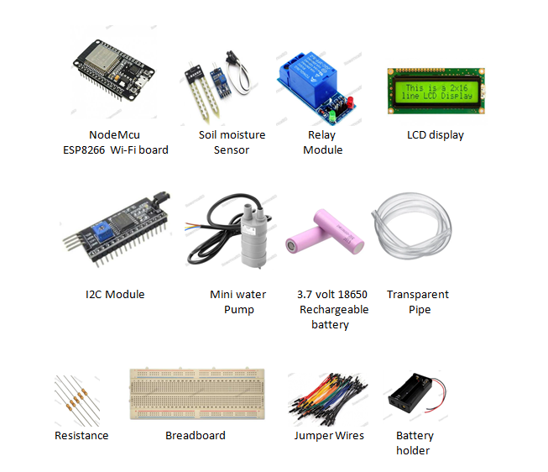

Circuit Design:

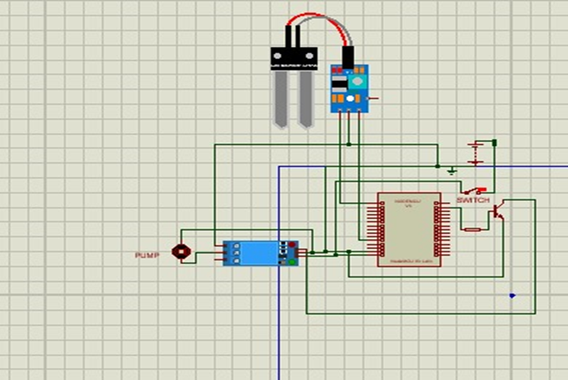

**Multidisciplinary Approach:**

The Automatic Irrigation System project involves a multidisciplinary approach, drawing on expertise from various fields to create an integrated and effective solution. Here's how different disciplines contribute to the project:

1.**Electrical Engineering**: Designing and implementing the electronic components, including the NodeMcu ESP8266 board, Relay module, and LCD display.

2.**Computer Science / Software Engineering**: Developing the software that runs on the NodeMcu ESP8266 board, facilitating data analysis, decision-making, and remote control.

3.**Mechanical Engineering:** Designing the mechanical components related to water distribution, such as the Mini Water Pump and Mini Water Pipe.

4.**Environmental Science:** Providing insights into optimal soil conditions and plant moisture requirements for effective irrigation.

5.**Data Science:**Analyzing and interpreting data collected by sensors to make informed decisions regarding irrigation schedules.

6.**Human-Computer Interaction (HCI):** Designing a user-friendly interface through the LCD display for easy monitoring and interaction with the system.

7.**Agricultural Science**: Integrating agricultural knowledge to ensure the system caters to the specific needs of different crops.

8.**Wireless Communication**: Implementing wireless communication protocols for data transmission using the Nodemcu ESP8266 board.

9.**Power Management**: Ensuring efficient power usage and management, considering the portable power source (3.7V Rechargeable Battery).

10.**Project Management:** Planning and organizing the development of the project, ensuring it stays within specified timelines and resources.

1. **Sustainability:** Incorporating sustainable practices, such as water conservation, in alignment with environmental and ecological principles.

12.**Security Systems**: Implementing security measures, such as motion sensors, to detect and respond to potential threats to the system.

13.**Urban Planning (for urban applications):** Considering urban planning principles for integrating smart irrigation systems in urban landscapes.

14.**Education and Outreach:** Providing educational value and outreach potential, making the project a valuable tool for academic learning and community engagement.

15.**Entrepreneurship and Innovation:** Creating opportunities for entrepreneurship by developing a technological innovation that can be further commercialized.

This multidisciplinary approach ensures that the Automatic Irrigation System is not only technologically robust but also considers environmental, social, and economic aspects for a holistic and sustainable solution.

**Safety Issues:**

When working with an automatic irrigation system, it's important to follow safety guidelines to ensure the well-being of both individuals and the environment. Here are some safety measures to consider:

1.**Electrical Safety**: If the irrigation system involves electrical components, ensure that all wiring and connections are properly insulated and protected from water exposure. Use waterproof junction boxes and follow electrical codes and regulations.

2.**Water Source Safety**: If the system is connected to a pressurized water source, such as a municipal supply or well, ensure that the water source is safe and potable. Regularly test the water quality to ensure it is free from contaminants that could affect plants, animals, or humans.

3.**Chemical Handling**: If fertilizers, pesticides, or other chemicals are used in conjunction with the irrigation system, carefully follow the manufacturer's instructions for storage, handling, and application. Wear appropriate protective gear, such as gloves and goggles, when working with chemicals, and store them in designated, secure areas away from children, pets, and food storage areas.

4.**Maintenance and Repair**: Regularly inspect and maintain the irrigation system to identify any potential hazards, such as leaks, damaged wiring, or malfunctioning components. Address any issues promptly and safely. If repairs require specialized knowledge or skills, consult a professional technician or contractor.

5.**Water Conservation**: While automatic irrigation systems are designed to optimize water usage, it's essential to avoid water waste. Ensure that the system is properly calibrated to deliver the right amount of water and adjust the settings based on weather conditions and plant needs. Regularly check for leaks, blockages, or overspray to prevent unnecessary water loss.

6.**Warning Signs and Markings**: If the irrigation system utilizes underground pipes or wiring, ensure that these are clearly marked to prevent accidental damage during excavation or landscaping activities. Use warning signs or flags to indicate the presence of buried irrigation components.

7.**Education and Training:** Ensure that individuals responsible for operating

or maintaining the irrigation system receive proper training and understand the safety protocols. Educate users about the system's features, emergency shutdown procedures, and any specific safety considerations.

8.**Compliance with Local Regulations**: Familiarize yourself with any local regulations, permits, or guidelines related to the installation and operation of automatic irrigation systems. Adhere to these regulations to ensure compliance and safety.

It's important to prioritize safety at all stages of working with an automatic irrigation system. Regular maintenance, proper installation, and adherence to safety guidelines will help ensure the system's effectiveness while minimizing risks to people, property, and the environment.

**Multiple Stake Holders:**

1. **Agricultural Community:**

The agricultural community comprises farmers, growers, and other individuals involved in agricultural practices. They are key stakeholders in the context of an automatic irrigation system as they directly benefit from the system's ability to optimize water usage, improve crop yields, and reduce labor requirements. Automatic irrigation systems offer convenience and efficiency to farmers by automating the irrigation process, allowing them to focus on other important tasks such as crop management, pest control, and harvesting. These stakeholders can implement automatic irrigation systems on their farms to enhance water management practices, increase productivity, and promote sustainable agriculture.

1. **Environmental Agencies**:

Environmental agencies are organizations responsible for monitoring and managing environmental resources and promoting environmental sustainability. They play a vital role in the adoption and promotion of automatic irrigation systems due to their potential for water conservation and efficient resource utilization. By encouraging the use of these systems, environmental agencies can contribute to the preservation of water resources, reduction of water waste, and mitigation of environmental impacts associated with traditional irrigation methods. They can also provide guidance, regulations, and incentives to promote the implementation of automatic irrigation systems as part of sustainable agricultural practices.

1. **Educational Institutions:**

Educational institutions, such as universities, research centers, and agricultural schools, have a significant interest in automatic irrigation systems. These institutions often conduct research and provide education on sustainable agriculture, water management, and technology-driven solutions. Automatic irrigation systems serve as practical examples for students and researchers to study, analyze, and improve upon. Educational institutions can integrate automatic irrigation systems into their curriculum, conduct research on their effectiveness, and provide training programs for farmers and agricultural professionals. By doing so, they contribute to the dissemination of knowledge and the development of innovative practices in the agriculture industry.

4**) Startups and Entrepreneurs:**

Startups and entrepreneurs play a crucial role in the development, production, and distribution of automatic irrigation systems. They are responsible for designing and manufacturing innovative irrigation technologies, developing software and control systems, and providing installation and maintenance services. Startups and entrepreneurs bring new ideas and solutions to the market, driving the advancement of automatic irrigation systems. They often leverage emerging technologies such as Internet of Things (IoT), data analytics, and remote monitoring to enhance the functionality and efficiency of these systems. By addressing the needs of farmers and the agricultural industry, startups and entrepreneurs contribute to the adoption and expansion of automatic irrigation systems, fostering sustainable and technologically advanced farming practices.

Overall, these stakeholders, including the agricultural community, environmental agencies, educational institutions, startups, and entrepreneurs, are interconnected and have a shared interest in promoting the adoption and advancement of automatic irrigation systems. Through collaboration and knowledge sharing, they can collectively contribute to sustainable agriculture, efficient water management, and the development of innovative solutions for the challenges facing the agricultural sector.

**Working Procedure:**

1. The Soil Moisture Sensor measures soil moisture levels, while the I2C module gathers real-time temperature and humidity data. The NodeMcu ESP8266 board processes this information.
2. Using Wi-Fi connectivity, the NodeMcu ESP8266 board wirelessly transmits the environmental data to a connected device, providing remote monitoring and control.
3. The NodeMcu ESP8266 board, in conjunction with the Relay Module, analyzes soil moisture levels. If moisture falls below the optimal threshold, the Relay Module activates the Mini Water Pump, initiating automated irrigation in specific dry areas.
4. Manual control is facilitated by the Breadboard, Jumper Wires, and a potential inclusion of a Tactile Push Button. Users can activate the Mini Water Pump manually for on-demand irrigation.
5. Power the system with a 3.7V Rechargeable Battery, for providing a sustainable and efficient energy source for continuous operation we use Tp4056 charging module, ensuring uninterrupted plant care.
6. The wires are used for connecting various components, ensuring the proper flow of electrical signals and power between them.

**Estimated Budget :**

|  |  |  |
| --- | --- | --- |
| **No.** | **Component Name** | **Price BDT** |
|  |  |  |
| **1** | NodeMcu ESP8266 board | 650 |
|  |  |  |
| **2** | Soil moisture Sensor | 700 |
|  |  |  |
| **3** | 5-volt single channel Relay | 150 |
|  | module |  |
| **4** | 16X2 display module | 450 |
| **5** | I2C mocule | 300 |
|  |  |  |
| **6** | 1 kΩ Resistance | 10 |
|  |  |  |
| **7** | Tree | 200 |
|  |  |  |
| **8** | Jumper wires | 150 |
|  |  |  |
| **9** | Mini water pump | 200 |
|  |  |  |
| **10** | One meter transparent pipe | 150 |
|  |  |  |
| **11** | 3.7 volt 18650 Rechargeable | 200 |
|  | battery |  |
| **12** | Tp4056 charging module | 70 |
|  |  |  |
| **13** | Battery holder | 60 |
|  |  |  |
| **14** | Power switch | 10 |
|  |  |  |
| **15** | PV board | 100 |
| **16** | Glue Gun | 350 |
|  |  |  |
| **17** | Breadboard | 100 |
|  |  | **Total:** 4160/= |
|  |  |  |

**Final Budget :**

|  |  |  |
| --- | --- | --- |
| **No.** | **Component Name** | **Price BDT** |
|  |  |  |
| **1** | NodeMcu ESP8266 board | 650 |
|  |  |  |
| **2** | Soil moisture Sensor | 700 |
|  |  |  |
| **3** | 5-volt single channel Relay | 150 |
|  | module |  |
| **4** | BC547 Transistor | 5 |
| **5** | Dot board | 150 |
|  |  |  |
| **6** | 10 kΩ Resistance | 10 |
|  |  |  |
| **7** | Tree | 200 |
|  |  |  |
| **8** | Jumper wires | 150 |
|  |  |  |
| **9** | Mini water pump | 200 |
|  |  |  |
| **10** | One meter transparent pipe | 150 |
|  |  |  |
| **11** | 3.7 volt 18650 Rechargeable | 200 |
|  | battery |  |
| **12** | Tp4056 charging module | 70 |
|  |  |  |
| **13** | Battery holder | 40 |
|  |  |  |
| **14** | Power switch | 10 |
|  |  |  |
| **15** | Tp4056 double charging module | 110 |
| **16** | Glue Gun | 350 |
|  |  |  |
| **17** | Female Header | 30 |
|  |  | **Total:** 3175/= |
|  |  |  |

**Conclusion :**

In bringing together the NodeMcu ESP8266 board, Soil Moisture Sensor, Relay module, LCD display, I2C module, Breadboard, Jumper wires, Mini water pump, Mini water pipe, and a 9V Battery, our Automatic Irrigation System marks a significant leap in sustainable plant care.

This intelligent system not only ensures precise irrigation based on real-time soil moisture data but also embraces user-friendly technology with the LCD display. The synergy of components fosters an environment where water conservation takes center stage, addressing the global challenge of excessive water use in traditional irrigation.

By integrating smart technologies and eco-conscious design, our Automatic Irrigation System is not just a project; it's a commitment to responsible agriculture. It stands as a beacon for efficient water management, harnessing the power of innovation for greener, more sustainable landscapes.